Title: Short and Concise, no more than 15 words

Author^{1*}, author² (use 1, 2 if different Department or University names)
¹Department, University/Institution, Address, Country
²Department, University/Institution, Address, Country
Email¹, Email² (Make sure all author's emails are written)

Article Information | Abstract
Article history  Received: filled by the editor  Revised: filled by the editor  Accepted: filled by the editor  Keywords: type 3-5 keywords, separating them with a semicolon (;) between them | The content of the abstract is between 150-300 words. One paragraph is enough. The abstract should provide the context or background of the community activity and state the main objective of the service in 1-2 sentences. Describe the necessary procedures used during the community activities, including selecting research subjects and methods of observation and analysis. Describe the main outcomes measured for each subject group on implementing community engagement. If possible, summarize the main findings, including specific effect sizes and their statistical significance. State the main conclusions, emphasizing new and important aspects of the observations on the issue of community engagement.
 | © 20xx Some rights reserved

INTRODUCTION

The Introduction section should provide a concise yet comprehensive background of the topic to highlight its relevance and urgency. It must clearly state the main problem while avoiding an overly detailed explanation of theories. A brief review of relevant literature is necessary to position the study within existing research and to show the gap or need that this paper intends to address. References should be cited in parentheses using the format (author, year).

Furthermore, this section should present the proposed approach, idea, or solution, emphasizing the contribution of the research or service activity, whether in academic or practical terms. The introduction should end with a clear statement of purpose, outlining the direction of the paper and the expected outcomes.

To maintain consistency, headings should follow the provided style: Heading 1 for main sections, Heading 2 for subsections, and Heading 3 if needed for sub-subsections.

References
References and citations should follow the bracketed author–date format, for example (Author, Year). When citing a direct quotation, the reference must also include the exact page number from which the quotation is taken, e.g., (Davis, 2003, p. 15). The author–date system may be applied either as (Kosko, 1999) or integrated into the sentence, such as according to Kosko (1999).... Always use the author’s surname followed by the year of publication. To simplify citation management and improve efficiency, it is recommended to use reference management tools such as EndNote, Mendeley, or Zotero.

MATERIALS AND METHODS

The Materials and Methods section presents the primary resources utilized in the service activities, along with the approaches employed for problem-solving and analysis

Materials
The materials listed in this section are limited to the essential ones and should be specified along with their brands. Likewise, the equipment described here only includes the primary tools used in the community service activities, accompanied by their respective brands.
Methods
This section presents the method applied in carrying out community service activities. The method should explain the chronological stages of the program, including the design of the activities, the implementation procedures, the instruments employed, and the analytical techniques used to address the identified problems. Furthermore, the explanation of the process must be supported by relevant references to ensure its scientific validity.
Commonly adopted approaches in community service activities may be utilized, such as Participatory Rural Appraisal (PRA), Rapid Rural Appraisal (RRA), Participatory Research and Development (PRD), Participatory Action Research (PAR), Problem-Based Learning (PBL), Experiential Learning, Project-Based Learning (PjBL), or other comparable methods.

RESULTS AND DISCUSSION
The Results and Discussion section should provide an objective description of the findings and must align with the objectives of the service activities. The discussion should be supported by relevant references and bibliographic sources. Results may be presented in the form of figures, tables, or other visual aids to enhance reader comprehension. Both qualitative and quantitative analyses should focus on addressing the research problems. This section should comprehensively describe the activities undertaken, including the underlying concepts, design, hypotheses (if applicable), experiments, observational data, and their analysis.
The outcomes must be measurable in order to assess the level of success achieved by the service partners, rather than the service team itself. Furthermore, the results should be compared with similar activities, highlighting the contributions, strengths, and limitations of the service activities carried out.

General Requirements
The manuscript must be a minimum of six pages, including appendices. The required font is Times New Roman, following the style and size demonstrated in this template, except for algorithms or programming scripts, which will be described in a separate section. To optimize formatting, authors are encouraged to maintain an even number of pages.

Equation
It also still uses styles. Use Microsoft Equation with the Insert | Object... command to write mathematical equations. If you can't find it, you should install it first. If this is not possible, click on the toolbars for simple equations that are not a problem to type manually.
(1)
Use the Equation style to write equations like the one above. Make sure you don't forget to write the equation number in order of appearance :-). This equation number is written in the right parenthesis. Refer to the Equation in this way: in Equation (1) and so on. In writing equations, use font size 9 for variables, while for powers and indices, use font size 8. Fonts in equations are in italic style, except for numbers.

Tables
Each table must be numbered sequentially and provided with a title. Tables should be left-aligned and formatted consistently, avoiding unusual or inconsistent styling. Use the Insert Table feature (Table | Insert | Table…) and apply the “Table Grid” style from the AutoFormat menu. Within the text, tables should be cited with an uppercase “T,” for example: “...as shown in Table 1.”
Table 1. Table title, use sentence case (initial letter capitalized)
No | This line | Bold
1 | This is the table content; if it is not enough, you can reduce the font size to 8 points. Don't go any smaller than this unless you want your readers to have sore eyes. | Table content font Regular

Table 1. Solution of dedication

Problem | Solution | Output
There is no standard for organizing teaching and learning activities in blended or online learning systems. | Assistance in the preparation of standard operating procedures for blended learning implementation | SOP KBM
Non-optimal use of teleconference media and teaching materials in online learning. | Needs analysis and clear SOPs for the provision/preparation of teaching materials | SOP for the preparation and use of teaching materials

Table 2. Changes resulting from service activities

Initial Condition | Intervention | Condition Change
There is still low awareness among students to keep the school environment free from rubbish. | Educate and transfer environmental skills to MIN 3 Aceh Barat students | There were changes in the aspects of ecological knowledge (35 students), ecological behavior (35 students), ecological emotions (32 students), and ecological ethics & awareness (30 students) after the intervention using the snakes and ladders board game.
Try not to cut the Table on different pages, unless it is more significant than one page. If it must be truncated, do not forget to rewrite the row headers for each column, give the same table sequence number, and replace the title with Continuation. The table title does not end with a period. Tables with a width of more than 1 column must be placed at the beginning or end of the page, while tables with a width of less than 1 column are placed freely as long as they are placed after the sentence that refers to them.

Figure
As with tables, ensure each image has a sequential number and title. Make the figure you use look professionally made and do not need to be framed. Make sure to use grayscale images. Use the Image Title style for this format. Images are centre-aligned. Remember, the image must also be referred to in the text by writing something like, ‘... if the message shown in Figure 1 appears, then Macro Security should be set to Medium’ (the image is written with a large ‘G’). The title of the figure does not end with a complete stop. For images with a width of more than 1 column, the position of the image must be placed at the beginning or the end of the page, while images with a width of less than 1 column are placed freely. However, these small images should not be placed before the sentence that refers to them, let alone before the paper's title.
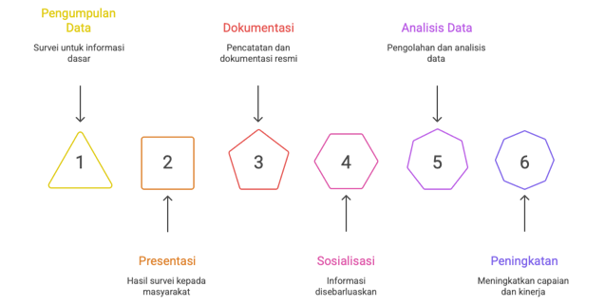
Fig. 1. Figure title, also in sentence case (initial letter capitalized)
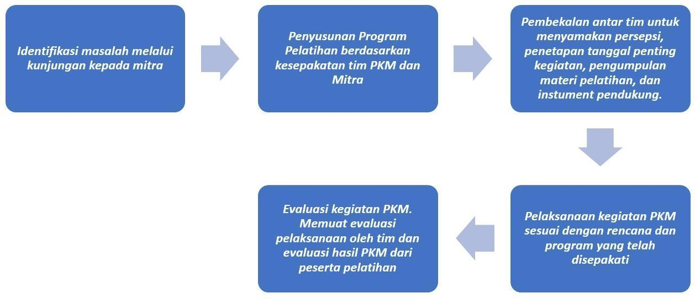
Fig. 2. PKM activity stages
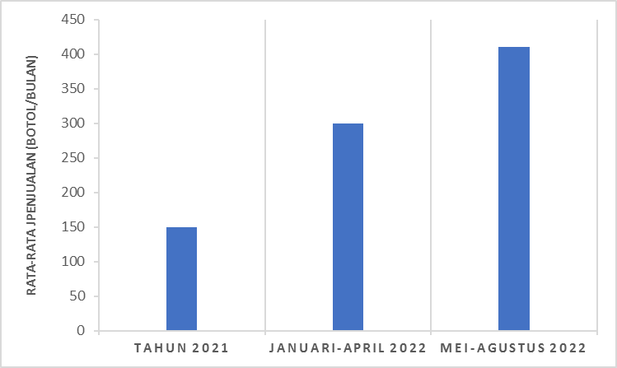
Fig. 3. Increased sales of herbal products

CONCLUSION
Conclusions are made in one paragraph that contains:
- The steps of data collection and implementation of the method are carried out.
- The main contribution that is measurable and impacts the community from the activities carried out.
- Limitations of the results of the activities carried out
- Recommendations for further service activities based on the limitations of the results achieved.
- Scope for future work

ACKNOWLEDGEMENTS
Acknowledgments are at least addressed to the Institution and service partners.

REFERENCES
The references must contain at least 20 references referring to primary sources and include links to show the references can be accessed. Avoid using sources from websites or similar pages that lack reliable scientific sources. The title of the references section above is not numbered. You can easily create this format with the help of the EndNote, Mendeley, or Zotero application. If this application is not available on your computer, it is not difficult to use the format in the example below (APA Style). For all authors, write the last name followed by the abbreviated middle and first name. Only published papers (book title, journal name and volume number) are italicized. Note that for references from the Internet, all parts of the reference are still written in full. Here is an example of writing a reference.
Don't forget to return the Macro Security settings to their original state after editing the Wikrama Parahita: Jurnal Pengabdian Masyarakat.
The reference list is arranged in the following manner and sorted alphabetically.

Amanah, S. (2007). Makna Penyuluhan dan Transformasi Perilaku Manusia. Jurnal Penyuluhan, 3(1), 63–67. https://doi.org/10.25015/penyuluhan.v3i1.2152
Aniuranti, A., Tsani, M. H. N., & Wulandari, Y. (2021). Pelatihan penyusunan Ice Breaking untuk penguatan kompetensi calon guru. ABSYARA: Jurnal Pengabdian Pada Masyarakat, 2(1), 85–93. https://doi.org/10.29408/ab.v2i1.3578
Anwar, M. R. (2019). Guru PAUD dan Kemampuan Public Speaking di Era MEA. Jurnal Lonto Leok, 2(1), 56–61. http://unikastpaulus.ac.id/jurnal/index.php/jilpaud/article/view/338/227
Budaraga, I. K., & Devi, W. S. (2021). Pengabdian kepada Masyarakat Peningkatan Kualitas Usaha Keripik Talas Asyifa Oleh-oleh. Prosiding Seminar Nasional Pengabdian Kepada Masyarakat, 1(1), 172–180. https://jurnal.fp.uns.ac.id/index.php/pengmas/article/view/1963
Harefa, A. (2007). Agar Menulis-Mengarang Bisa Gampang (4th ed.). Gramedia Pustaka Utama. https://books.google.co.id/books?id=-DliaG-3C64C&dq
Ibiz Coach. (2018). Inilah Perbedaan Antara Mentoring, Consulting, Training, dan Coaching. https://ibizcoach.com/perbedaan-mentoring-consulting-training-dan-coaching/
Kemendikbud. (2019). Neraca Pendidikan Daerah: Data Uji Kompetensi Guru. Kemendikbud. https://npd.kemdikbud.go.id/?appid=ukg,
Mallapiang, F., Kurniati, Y., Syahrir, S., Lagu, A. M. H., & Sadarang, R. A. I. (2020). Pengelolaan sampah dengan pendekatan Asset-Based Community Development (ABCD) di wilayah pesisir Bulukumba Sulawesi Selatan. Riau Journal of Empowerment, 3(2), 79–86. https://doi.org/10.31258/raje.3.2.79-86
Nalhadi, A., Syarifudin, S., Habibi, F., Fatah, A., & Supriyadi, S. (2020). Pemberdayaan Masyarakat dalam Pemanfaatan Limbah Rumah Tangga menjadi Pupuk Organik Cair. Wikrama Parahita : Jurnal Pengabdian Masyarakat, 4(1), 43–46. https://doi.org/10.30656/jpmwp.v4i1.2134
Nurgesang, F. A., & Ridlwan, P. P. M. (2019). The Manufacturing of Banana Cutting Machine for Making Chips with Capacity of 35 kg/h to Improve Productivity of a Home Industry in Putat Village, Gunungkidul, Yogyakarta. Prosiding SNTTM XVIII, 1–7. http://prosiding.bkstm.org/prosiding/2019/TM11.pdf
Oktaviana, F., Hanidian, O., Aji, B. S., & Baihaqi, I. (2020). Pelayanan Administrasi Desa Berbasis Online di Desa Paremono. ABDIPRAJA (Jurnal Pengabdian Kepada Masyarakat), 1(1), 49–56. https://doi.org/10.31002/abdipraja.v1i1.3205
Palenti, C. D. (2021). Peningkatan Keterampilan Komunikasi melalui Participatory Learning Pada kegiatan Pemberdayaan Masyarakat. Diklus: Jurnal Pendidikan Luar Sekolah, 5(1), 87–98. https://doi.org/10.21831/diklus.v5i1.37074
Permana, E. P. (2021). Pengaruh Media Pembelajaran Wayang Kertas Terhadap Nilai Karakter Siswa Sekolah Dasar. Prima Magistra: Jurnal Ilmiah Kependidikan, 2(2), 190–196. https://doi.org/10.37478/jpm.v2i2.1028
Prastyan, R. D. N. (2019). Penguatan Pendidikan Karakter Anak SD Melalui Konsep Pembelajaran Berbasis Kesenian Budaya Daerah dan Permainan Tradisional di Kampoeng Dolanan Nusantara Borobudur Magelang. Seminar Nasional Pagelaran Pendidikan Dasar Nasional (PPDN), 1(1), 93–101. http://www.seminar.uad.ac.id/index.php/ppdn/article/view/1446
Yuwanita, E. (2016). Keefektifan Penggunaan Media Video Pembelajaran Untuk Meningkatkan Hasil Belajar Siswa Pada Mata Pelajaran Dasar Teknologi Menjahit di SMK Negeri 3 Pacitan. Skripsi. Semarang: Universitas Negeri Semarang. http://lib.unnes.ac.id/28353/1/5401411100.pdf

